Wooden Spoon Mermaids
(craft from Glued to My Crafts)

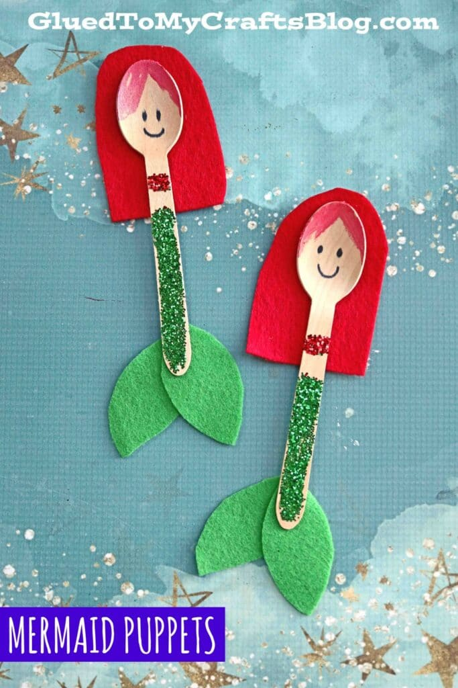
Supplies:
- Wooden craft spoons
- Glue
- Red and green construction paper
- Red and green glitter
- Marker
- Scissors

Directions:
- Using the glue, add glitter for the body and tale of the mermaid. Set aside to dry.
- Using the construction paper, cut out fins for the tail and hair.
- Draw the mermaid’s face.
- Glue the hair and mermaid tail to the spoon.
- Add any additional details you would like—feathers, glitter, flowers, anything!

